

The Lighthouse
Zion & Trinity Lutheran Churches
950 Huron
St. Ignace, MI 49781

Address Service Requested

Nonprofit Org.
U.S. Postage
PAID
St. Ignace, MI 49781
Permit No. 55

THE LIGHTHOUSE

Newsletter for December 2015

19 The sun will no more be your light by day, nor will the brightness of the moon shine on you, for the LORD will be your everlasting light, and your God will be your glory Isaiah 60:19

Message from Our Pastor

Dear Sisters and Brothers in Christ,

I love the season of Advent, the color of the season is blue or purple, and not the green we have been accustomed to the last few months. Now don’t get me wrong, I like the green, but it’s time for change. It’s also a season of Reflection and Hope. It’s not hard to see we live in a world longing for hope, wars are raging, and people are fleeing their countries because of it. Winter is here and though beautiful in many ways, it to poses hardships. At times we can seem to be stuck in one place due to cold and snow; it’s also a time when the bills can stack up with the costs of heating our homes. When we look at all that, we grasp for a little hope and where does that come from? Our Lord and Savior Jesus Christ!

During Advent I usually reflect on all the events that happened in my life in the last year, some good and some not so good. Then when I see the mangers popping up all over, due to the Christmas season that will begin this month, I begin to look at where Christ is in all of those events. I recently talked to a dear friend and she told me of an event in her life. She was in the grocery store, and she struck up a conversation with a man whom seemed lonely. They had a wonderful conversation and soon they parted ways and continued to shop. When she went to check out and pay for her items, the cashier told her that they had already been paid for by the man she was talking to. Christ was present there. Or when someone was struggling and a dear friend gave them a hug and just listened to them in their time of need. Christ was present there. I am very thankful to say I could go on and on with stories like that. I give thanks for the season of Advent that reminds me to reflect on where Christ is in my life and in a world longing for hope. It all began with a baby, our Emmanuel (which means God among us) who would preach and teach, care for those whom society neglected, and finally go to the cross taking on all our pain and sin, to die for us and then rise again giving us eternal life!

Christ, who is our hope, is with us now and will come again! Thanks be to God!!

Yours in Christ, Pastor David

Advent


Advent begins November 29! Advent is a time to focus inward and prepare our hearts and lives for Christ. This is the countdown and earnest waiting for the Messiah. Please take some time during this season to:

- Worship weekly
- Pray daily
- Read your Bible daily
- Practice generosity
Newsletter

The Newsletter was not adopted.

Trinity Christmas Dinner

Join us on Saturday, December 5th for Trinity’s Third Annual Christmas Dinner. Appetizers at 5 pm, dinner at 6 pm.

Noisy Offering

The noisy offering for December 6th will go for the Mackinac County Children’s Toy Drive.

Annual Christmas Musicale

Come enjoy the music at the Annual Christmas Musicale at the United Methodist Church on December 6th at 6:30 pm.

NOIZ

NOIZ will meet on December 13th for Bowling from 1 p.m. to 3 p.m. There will be pizza from 3 p.m. to 4 p.m. followed by caroling. Join us for caroling and spreading Christmas cheer!

Confirmation

Confirmation will meet on the first and third Sundays at 6 pm.

Sunday School Christmas Program

The Sunday School Christmas Program will be on December 20th. Come and enjoy!

Christmas Services

Join us as we celebrate the birth of our Savior on Christmas Eve. Trinity will meet at 5 p.m. and Zion at 8:00 p.m.

Food Pantry/Area Hope

During the month of December Zion will be collecting food cans for the Food Pantry. During the winter months, the need always increases.
At this time, Area Hope is in need of disposable diapers.

Contact Max

Anyone wishing to contact Max Coburn or send him a Christmas card, his telephone number is 231-373-6404 and his address is Independence Village, 965 Hager Drive, #218, Petoskey, MI 49770.

Spartan Labels


We are now collecting Spartan Labels to raise money for Zion. Collect the UPC labels from any Spartan product and bring them to the church. We have 320, we need to reach 1000.

Poinsettias

Anyone wishing to order poinsettias for the
Christmas Eve service. Contact Betsy Turf at
906-643-1512 for information.

Congratulations!

Congratulations to Fred, Sandy & A.J. Feleppa on A.J.’s adoption, baptism and first communion.
Also congratulations to Pastor David, Sunday was his first baptism.
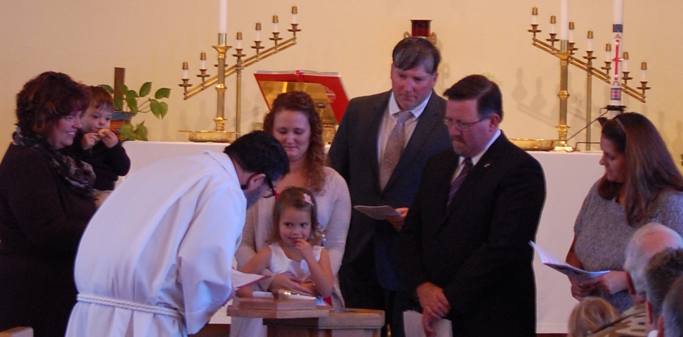

(To see color photos, go to the online version of the newsletter at http://zionstignace.com/home.html)
Holiday Open House

Share the Holiday Spirit in downtown St. Ignace on December 4th. G-man Entertainment starts at 4:30 p.m. Straits Area Chorale at 5:45 p.m. Santa arrives at Arnold Line Dock #1 at 6 p.m. followed by the Christmas Tree Lighting and other great activities.

Evergreen Living Center Craft Show

There will be an Evergreen Living Center Resident Craft Show in the Tribal Board Room, upstairs at the hospital to raise money for their Activities Department. Monday, December 14th, 4 – 6 pm and Tuesday, December 15th, 9 am to 2 pm. Get some Christmas shopping done while helping a great cause.

Prayer List

( If you would like someone added to the prayer list, please fill out a yellow card or call the church)


Jim Dyer, Carl & Mary Belonga, LaTaunya Paquin, Phil Richel, Barb Lehto, Charlie Lamoreaux, Beth Ann Amacher, Joel Morabito, Joanne Truman, Greg Mitchinson, Kelli Morrison, Jim Rose, Troy Johnston, Dave & Lois Movalson, Pega Kennedy, Jim Ryerse, Steve Ingalls, Tom Coffey, Lance Litzner, Jim Scott, J.C. Kelly, Kathy Perry, Sara Suchodolski, Lori Bowlby, Ann Yandell, Travis Rickley, Shirley Mitchinson, Howard Crisp, Marian Steiner, Kathy Borrello, Nadine & Linda Dandona, and Ed Idalski

Anniversaries in December

December 1 Dave & Lois Movalson
December 10 Jim & Jerri Rose
December 28 Tim & Sally Idalski

Birthdays in December

December 2 Andrea Insley
4 Bonnie Bergeron
- Joyce Gustafson
- Josh LaJoice
- Sue St. Onge
12 Trudy Olsen
14 Bill Harju
15 Tonya Winberg
17 Phil Schaeffer
20 Robby Olsen
22 Sally Idalski
23 Chase DeKeyser
24 Carol Elmblad
24 Toby Ferguson
25 Robert Marshall
26 Lorraine Graham
29 Barb Wilkins
30 Mike Lehto

Baptismal Anniversaries

December 2 Madison Olsen
3 Kelly LaJoice
7 Zoey Stenson
9 Brad Therrian
15 Rita LaVake
15 Connie Olsen
19 Joshua Feleppa
20 Lana Lennington
20 Sue St. Onge
24 Bernard Crouch
24 Katti Gamble
24 Alicia Garen
24 Cole Garen

25 Jordan Caldwell
27 Dawn Akers
27 Lucas Hammond
27 Brent Ruff
27 Jayce Ruff
27 Drew Stockero
28 Kristine Vallier
29 Barb Wilkins
30 Max Coburn

Zion Funeral Committee December-March

Team Leader: Lana Lennington (643-6576)
Co-leader: Marlene Olsen (643-9519)

Trinity Worship Families

Dec 6 Chalmers Family
Dec 13 Rose Family
Dec 20 Kennedy Family
Dec 24 Movalson Family
Dec 27 Baron Family

Servants for Zion

Ushers & Greeters
Dec 6 Jerry & Susan Fenlon
Dec 13 Martha Sjogren & Donna Harju
Dec 20 Confirmation Youth
Dec 24 Lana Lennington Family
Dec 27 Mike Lehto & Mike Herman

Lectors
Dec 6 Fred Feleppa
Dec 13 Judy Ryerse
Dec 20 Linda Wilkins
Dec 24 Richard Galor
Dec 27 Dawn Akers

Communion Assistants
Dec 6 Bailey Ryerse
Dec 13 Ryan LaVake
Dec 20 Emma Feleppa
Dec 24 Ellie Tielbar

Acolytes
Dec 6 Bailey Ryerse
Dec 13 Ryan LaVake
Dec 20 Emma Feleppa
Dec 24 Ellie Tielbar
Dec 27 Donovan Insley

Altar: Mike Herman
Money Counters: Lana Lennington & Nicole Garen

On December 20th we will be providing the service at Long-Term Care. Join us if you can, to spread the word of the Lord and Christmas cheer.

Council Meetings

Zion Council Meeting – 6:30 pm, December 15th
Trinity Council Meeting – 6 pm, December 16th

Zion’s Council Members

President: Lana Lennington 643-6576
Vice-President Paul Shepard 984-2069
Secretary: Lorraine Graham 643-8419
Co-Treasurers: Dawn Akers 643-7552
Co-Treasurers: Lana Lennington 643-6576
Fred Feleppa 643-6793
Jerry Fenlon 643-8730
Nicole Garen 298-0490
Tim Idalski 643-6574

Trinity’s Council Members

President: Jerri Rose 292-5570
Vice-President Tracy Movalson 292-5581
Secretary: Sharon Chalmers 292-5440
Treasurer: Pega Kennedy 292-5633
Co-Treasurer: Jim Rose 292-5570
Financial Secretary: Tom Gustafson 292-5460
WELCA: Pega Kennedy 292-5633
John Kennedy 292-5633
Jim Dyer 292-5433
Lois Movalson 292-5581

Treasurer's Report for Zion
January 1, 2015 to November 19, 2015
Income:
 | Amazon Smile Foundation | 12.58
 | Building | $ 303.00
 | Church Use Income | $ 150.00
 | Thrivent Financial Income | $ 719.00
 | General | $ 45,053.00
 | Trinity Share | $ 9,793.99
 | TOTAL |  | $ 56,031.57
Expenses:
 | Administration | $ 5,532.39
 | Benevolence | $ 4,939.29
 | Church Maintenance | $ 12,845.37
 | Education | $ 642.00
 | Parsonage Maintenance | $ 1,921.26
 | Pastoral | $ 22,125.46
 | Worship | $ 8,605.74
 | --To Building Fund | $ 188.00
 | --To LCF Loan | $ 0.00
 |  |  | $ 56,799.51
 |  |  | -767.94
***********************************************************
General fund balance: |  |  | -743.57
Kitchen/Building Fund balance |  |  | $ 1,113.57
General fund owes building fund: |  |  | $ 115.00
General fund owes Mission Endowment fund: |  |  | $ 7,995.00

Trinity Council Meeting
November 18, 2015

Those Present: Pega & John Kennedy, Jim & Jerri Rose, Tracy Movalson, Tom Gustafson, Sharon Chalmers, and Pastor David.
OPENING: The meeting was brought to order at 6:00 p.m. with Pastor reading a devotion entitled "Awake" by Dietrich Bonhoffer.
PASTOR'S REPORT: Pastor made 15 pastoral visits, the Bible Studies are going well, and he had one transfer request. Sharon and Ken are transferring their church membership to their new church in Arizona.
SECRETARY'S REPORT: Read and Approved
TREASURER'S REPORT: Read and Approved
FINANCIAL SECRETARY'S REPORT: Read and Approved
OLD BUSINESS:
1. Tracy and Sharon will work with the new scanner to document the church archives.
2. The council approved the purchase of workbooks for Bible Study.
3. There is a box downstairs for "toys for tots." We are also collecting paper goods and toiletries for the Hope Chest.
NEW BUSINESS:
1. The Community Dinner will be December 5th. We are asked to bring appetizers or Christmas cookies. Appetizers will start at 5:00 followed by dinner at 6:00.
2. A.J. Feleppa's baptism will be held at Zion Nov. 22. A luncheon will follow the service. All are invited.
The meeting was adjourned at 6:35 with the Lord's Prayer
Respectfully submitted,
Sharon Chalmers

Contact Information

Pastor David Tielbar may be reached at 906-984-2051 or at david.tielbar6@gmail.com. In an emergency, you can reach the Pastor’s cell phone at (563) 880-4512

Church telephone: 906-643-7870 - Answering machine
The secretary will usually be in the office on Tuesday and Thursday mornings from 9 - 12

To email the church is: ziontrinity950@yahoo.com
The website is at http://zionstignace.com/home.html
- Find us on facebook at www.facebook.com/zionstignace

Zion Evangelical Lutheran Church and Trinity Lutheran Church are congregations of the Northern Great Lakes Synod and the Evangelical Lutheran Church in America.

Merry Christmas!



Wishing You a Blessed Christmas!

